Chest pass
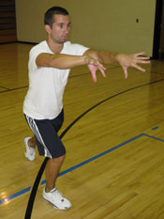
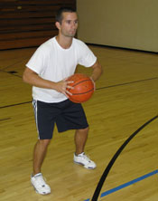
Level | Action
1 | Chest pass and catch off the wall from the red cone.
2 | Chest pass and catch off the wall from the yellow cone.
3 | Chest pass and catch off the wall from the blue cone.

Level | Action
1 | Bounce pass with a partner from the red cone.
2 | Bounce pass with a partner from the yellow cone.
3 | Bounce pass with a partner from the blue cone.
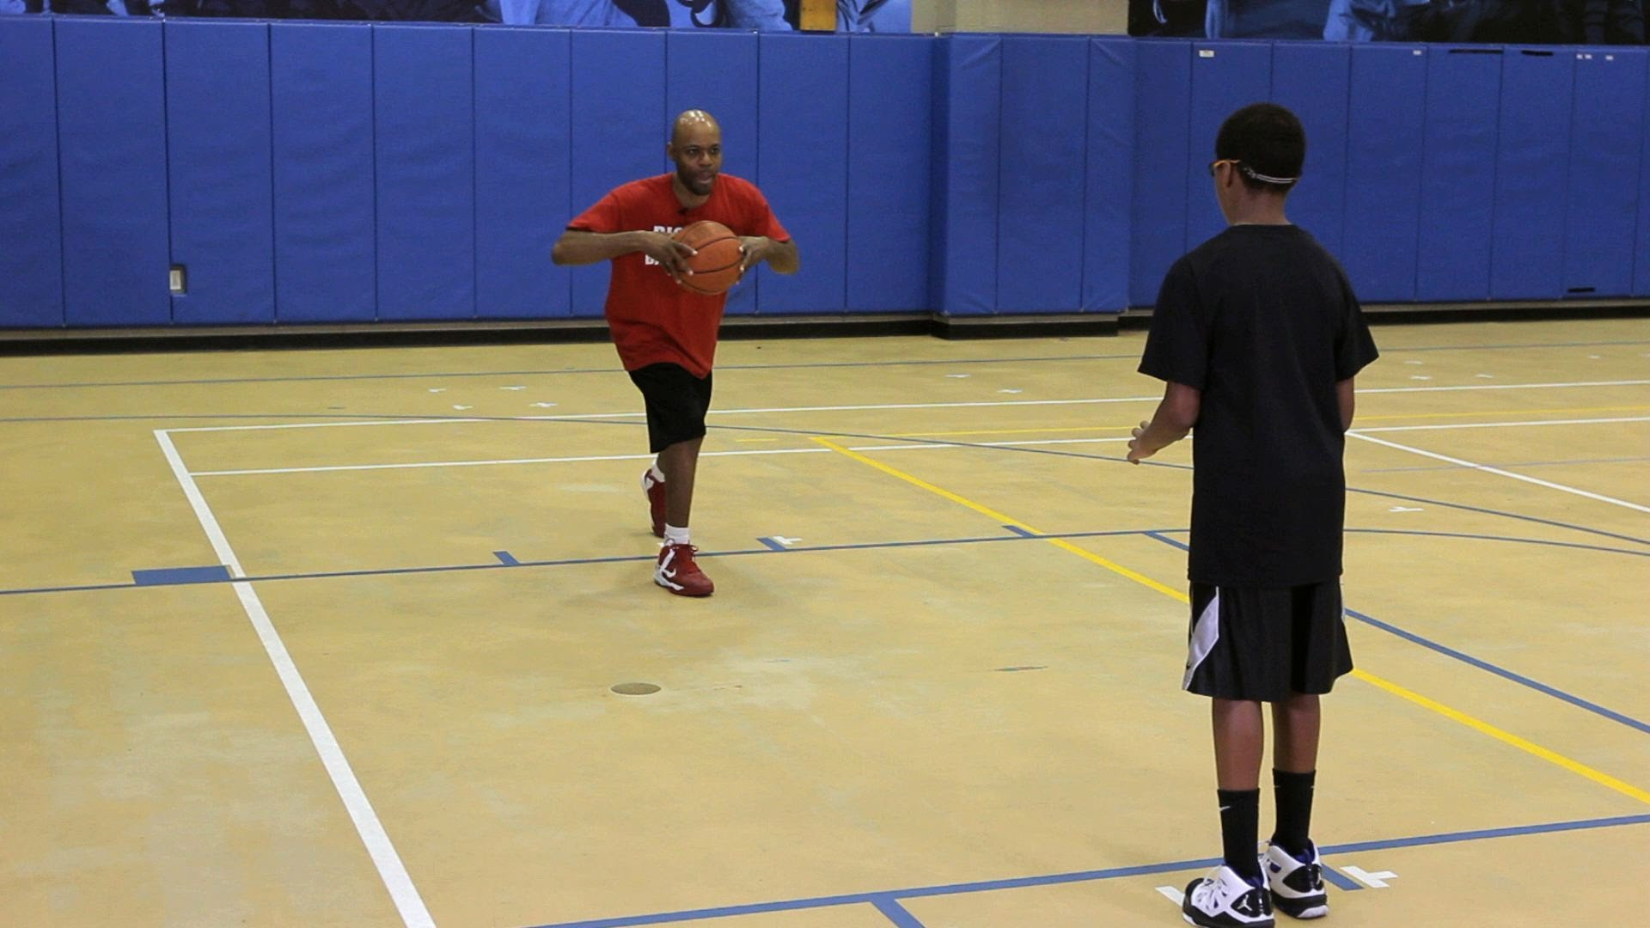
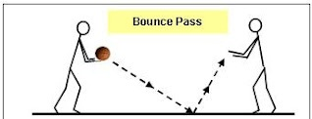
Bounce pass
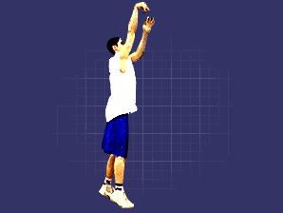
Set shot
Level | Action
1 | Set shot and score from the red cone.
2 | Set shot and score from the yellow cone.
3 | Set shot and score from the blue cone.
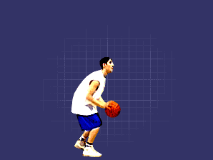
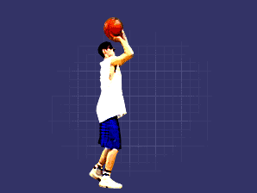
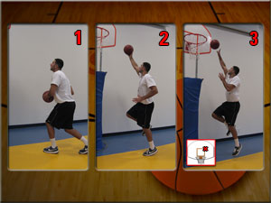
Lay up
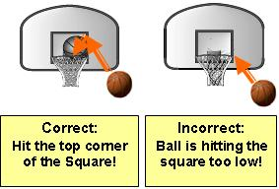

Level | Action
1 | Use the backboard to score with both hands.
2 | Use the backboard to score with your strongest hand.
3 | Use the backboard to score with your weakest hand.

Dribbling 1
Level | Action
1 | Dribble the ball whilst walking.
2 | Dribble the ball whilst jogging.
3 | Dribble the ball whilst jogging, changing between hands.
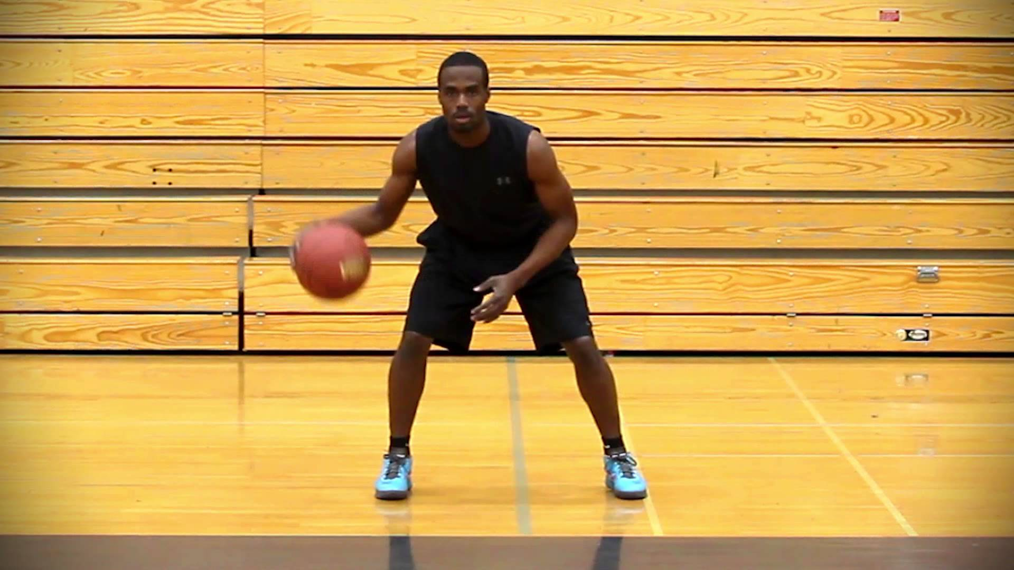


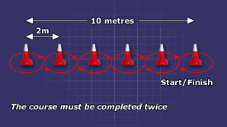
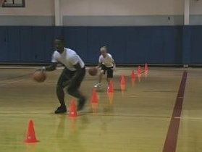
Dribbling 2
Level | Action
1 | Dribble the ball whilst walking, in and out of the cones.
2 | Dribble the ball whilst jogging, in and out of the cones.
3 | Dribble the ball whilst jogging, in and out of the cones, using both hands.

